# B.Sc. Project Work

Times New Roman Font size 21



Times New Roman Font size 21

**MD. ABDUR RAHMAN MD. ABDUR RAHMAN MD. ABDUR RAHMAN MD. ABDUR RAHMAN**

Times New Roman Font size 21

# August, 2023

Times New Roman Font size 12

**SURFACE MODIFICATION OF COTTON FABRIC TO IMPROVE DYE ABILITY WITH NATURAL DYES**



# B.Sc. Project Work

Times New Roman Font size 22

***A Project Work Submitted to the Uttara University for the Partial Fulfillment of the Degree of Bachelor of Science in Textile Engineering.***

Times New Roman Font size 12

Times New Roman Font size 12

**SUBMITED BY**

|  |  |  |  |
| --- | --- | --- | --- |
| **SL NO.** | **NAME** | **STUDENT ID** | **BATCH NO.** |
| **01** | **MD. ABDUR RAHMAN** | **2172461040** | **11** |
| **02** | **MD. ABDUR RAHMAN** | **2172461041** | **11** |
| **03** | **MD. ABDUR RAHMAN** | **2172461042** | **11** |
| **04** | **MD. ABDUR RAHMAN** | **2172461043** | **11** |
| **05** |  |  |  |

Times New Roman Font size 12

## DEPARTMENT OF TEXTILE ENGINEERING UTTARA UNIVERSITY

**August, 2022**



**DEDICATED TO**

**BELOVED PARENTS AND TEACHERS**

# DECLARATION

Times New Roman Font size 22

Times New Roman Font size 12

We, hereby declare that the present project work titled “**Surface modification of cotton fabric to improve dye ability with natural dyes”** is not submitted by us in any organization for the requirement of degree program. There is no information in this paper beyond the related references.

We affirm that the finding of this project is authentic and not manipulated from anywhere. We will be responsible for any kind of claim of this research.

Times New Roman Font size 12

|  |  |  |
| --- | --- | --- |
| **STUDENT’S NAME** | **STUDENT ID** | **SIGNATURE** |
| MD. ABDUR RAHMAN | 2172461040 | ....................................... |
| MD. ABDUR RAHMAN | 2172461040 | ………………………... |
| MD. ABDUR RAHMAN | 2172461040 | …………………………. |
| MD. ABDUR RAHMAN | 2172461040 | …………………………. |
| MD. ABDUR RAHMAN |  |  |

Times New Roman Font size 22

Times New Roman Font size 12

# DECLARATION CERTIFICATE

Certified that the project work entitled “**Surface modification of cotton fabric to improve dye ability with natural dyes**’’ is an experimental research work carried out by Md. Abdur Rahman, Md. Abdur Rahman, Md. Abdur Rahman and Md. Abdur Rahman under my supervision and that they have fulfilled the conditions laid down in the Uttara University ordinances. This dissertation may be considered for awarding the B.Sc. in Textile Engineering degree.

Times New Roman Font size 12

**SUPERVISED BY**

## Mohammad Saiful Islam

Senior Lecturer Department of Textile Engineering

Uttara University Uttara, Dhaka-1230 Bangladesh

Times New Roman Font size 21

# ACKNOWLEDGEMENT

Times New Roman Font size 12

First of all, we are extremely grateful to Almighty for His mercy and grace which helped us to complete the project work successfully.

We are thankful to our honorable teacher **Md. Abu Bakar Siddiquee,** Advisor, Department of Textile Engineering, Uttara University for his valuable advices for completing this work. We also would like to thank **Md. Humayun Kabir Khan**, Assistant Professor and Acting Chairman, Department of Textile Engineering, Uttara University for his guidance and encouragement during this project work.

We would like to express our humble gratitude and special thanks to our supervisor **Mohammad Saiful Islam,** Senior Lecturer, Department of Textile Engineering, Uttara University for his continuous supervision, suggestions and excellent co-operation during this project work.

We would like to express our cordial thanks to **Md. Maruf** for his help to complete our project.

September, 2021 The Authors

# ABSTRACT

Times New Roman Font size 21

To ensure the quality of garments is mandatory in ready-made garments (RMG) sector. Garments quality depends on seam strength, seam slippage, seam, stitch and so on. Chain stitch seam strength has been evaluated here on denim and twill fabric using cotton and polyester sewing thread at SPI 8, 10 and 12. It has been found that chain stitch seam strength increased by increasing SPI for both denim and twill fabric using cotton and polyester sewing thread. It has been found that the average chain stitch seam strength of polyester sewing thread sewed samples is higher than that of cotton sewing thread sewed samples for both denim and twill fabric. Finally, we have found that the average chain stitch seam strength of denim fabric is higher than twill fabric at different SPI.

# CONTENTS

|  |  |
| --- | --- |
|  | **PAGE NO.** |
| **ACKNOWLEDGEMENT** | **i** |
| **ABSTRACT** | **ii** |
| **LIST OF FIGURE** | **vi** |
| **LIST OF TABLES** | **vii** |
| **LIST OF SYMBOLS AND ABBREVIATIONS** | **ix** |

|  |  |  |
| --- | --- | --- |
| **CHAPTER ONE:** | **INTRODUCTION** | **1-3** |
|  | 1.1. Introduction | 2 |
|  | 1.2 Objective of project work | 3 |
| **CHAPTER TWO:** | **LITERATURE REVIEW** | **4-6** |
|  | 2.1 Review of recent research work | 5 |
| **CHAPTER THREE:** | **THEORETICAL BACKGROUND** | **7-11** |
|  | 3.1 Textile | 8 |
|  | 3.2 Textile fibre | 8 |
|  | 3.3 Yarn | 8 |
|  | 3.3.1 Types of yarn | 8 |
| **CHAPTER FOUR:** | **MATERIALS AND METHODS** | **12-21** |
|  | 4.1 Materials | 13 |
|  | 4.1.1 Fabric | 13 |
|  | **4**.1.2 Sewing thread (cotton) | 15 |
|  | 4.1.3 Sewing thread (polyester) | 15 |
|  | 4.1.4 Scissor | 16 |

|  |  |  |
| --- | --- | --- |
|  | 4.1.5 Measurement tape | 16 |
|  | 4.1.6 Marker pen | 17 |
|  | 4.1.7 Cutting chock | 17 |
|  | 4.1.8 Tesometric M350-CT | 18 |
|  | 4.1.9 Overlock sewing machine | 19 |
|  | 4.2 Methods | 20 |
|  | 4.2.1 Sample preparation | 20 |
|  | 4.2.2 Calculation of seam strength | 21 |
| **CHAPTER FIVE:** | **RESULTS AND DISCUSSION** | **22-35** |
|  | 5.1 Chain stitch seam strength of denim fabric at SPI 8 using cotton sewing thread | 23 |
|  | 5.2 Chain stitch seam strength of denim fabric at SPI  10 using cotton sewing thread | 23 |
|  | 5.3 Chain stitch seam strength of denim fabric at SPI  12 using cotton sewing thread | 24 |
|  | 5.4 Average chain stitch seam strength of denim fabric  at SPI 8, 10 and 12 using cotton sewing thread | 24 |
|  | 5.5 Chain stitch seam strength of denim fabric at SPI 8  using polyester sewing thread | 25 |
|  | 5.6 Chain stitch seam strength of denim fabric at SPI  10 using polyester sewing thread | 26 |
|  | 5.7 Chain stitch seam strength of denim fabric at SPI  12 using polyester sewing thread | 26 |
| **CHAPTER SIX:** | **CONCLUSIONS** | **34-35** |
|  | 6.1 Conclusion | 35 |
|  | 6.2 Limitations | 35 |
|  | **REFERENCES** | **36** |

**LIST OF FIGURES**

|  |  |  |
| --- | --- | --- |
| **Figure No.** | **Name of Figure** | **Page No.** |
| Fig.4.1 | Denim fabric | 13 |
| Fig.4.2 | Twill fabric | 14 |
| Fig.4.3 | Cotton sewing thread | 15 |
| Fig.4.4 | Polyester sewing thread | 15 |
| Fig.4.5 | Scissor | 16 |
| Fig.4.6 | Measurement tape | 16 |
| Fig.4.7 | Marker pen | 17 |
| Fig.4.8 | Cutting chock | 17 |
| Fig.4.9 | Tesometric M350-CT | 18 |
| Fig.4.10 | Overlock sewing machine | 19 |
| Fig.4.11 | Test Specimen | 20 |
| Fig.5.1 | Average chain stitch seam strength of denim fabric at  SPI 8, 10 and 12 using cotton sewing thread | 25 |
| Fig.5.2 | Average chain stitch seam strength of denim fabric at  SPI 8, 10 and 12 using polyester sewing thread | 27 |
| Fig.5.3 | Average chain stitch seam strength of twill fabric at SPI  8, 10 and 12 using cotton sewing thread | 29 |
| Fig.5.4 | Average chain stitch seam strength of denim fabric at  SPI 8, 10 and 12 using polyester sewing thread | 31 |
| Fig.5.5 | Comparison of average chain stitch seam strength of denim fabric at SPI 8, 10 and 12 using cotton and  polyester sewing thread | 32 |
| Fig.5.6 | Comparison of average chain stitch seam strength of  twill fabric at SPI 8, 10 and 12 using cotton and polyester sewing thread | 33 |

# LIST OF TABLES

|  |  |  |
| --- | --- | --- |
| **Table No.** | **Name of Table** | **Page No.** |
| Table 4.1 | Fabric specification of denim fabric | 13 |
| Table 4.2 | Fabric specification of twill fabric | 14 |
| Table 4.3 | Total number of sample | 21 |
| Table 5.1 | Chain stitch seam strength of denim fabric at SPI 8 using  cotton sewing thread | 23 |
| Table 5.2 | Chain stitch seam strength of denim fabric at SPI 10 using  cotton sewing thread | 23 |
| Table 5.3 | Chain stitch seam strength of denim fabric at SPI 12 using  cotton sewing thread | 24 |
| Table 5.4 | Average chain stitch seam strength of denim fabric at SPI 8, 10  and 12 using cotton sewing thread | 24 |
| Table 5.5 | Chain stitch seam strength of denim fabric at SPI 8 using  polyester sewing thread | 25 |
| Table 5.6 | Chain stitch seam strength of denim fabric at SPI 10 using  polyester sewing thread | 26 |
| Table 5.7 | Chain stitch seam strength of denim fabric at SPI 12 using  polyester sewing thread | 26 |
| Table 5.8 | Average chain stitch seam strength of denim fabric at SPI 8, 10  and 12 using polyester sewing thread | 26 |
| Table 5.9 | Chain stitch seam strength of twill fabric at SPI 08 using cotton  sewing thread | 27 |
| Table 5.10 | Chain stitch seam strength of twill fabric at SPI 12 using cotton  sewing thread | 28 |
| Table 5.11 | Chain stitch seam strength of twill fabric at SPI 12 using cotton  sewing thread | 28 |
| Table 5.12 | Average chain stitch seam strength of twill fabric at SPI 8, 10  and 12 using cotton sewing thread | 28 |
| Table 5.13 | Chain stitch seam strength of twill fabric at SPI 08 using  polyester sewing thread | 29 |

|  |  |  |
| --- | --- | --- |
| Table 5.14 | Chain stitch seam strength of twill fabric at SPI 10 using  polyester sewing thread | 30 |
| Table 5.15 | Table 5.15: Chain stitch seam strength of twill fabric at SPI 12 using polyester sewing thread | 30 |
| Table 5.16 | Average chain stitch seam strength of twill fabric at SPI 8, 10  and 12 using polyester sewing thread | 31 |
| Table 5.17 | Comparison of average chain stitch seam strength of denim fabric at SPI 8, 10 and 12 using cotton and polyester sewing  thread | 32 |
| Table 5.18 | Comparison of average chain stitch seam strength of twill  fabric at SPI 8, 10 and 12 using cotton and polyester sewing thread | 33 |

**LIST OF SYMBOLS AND ABBREVIATIONS**

|  |  |
| --- | --- |
| SPI: | Stitch per inch |



**CHAPTER ONE**

**INTRODUCTION**

Times New Roman Font size 22

# CHAPTER ONE: INTRODUCTION

## Introduction

Clothing (also known as clothes, apparel, and attire) are items which worn on the body. Typically, clothing is made of fabrics or [textiles](https://en.wikipedia.org/wiki/Textile), but over time it has included garments made from [animal skin](https://en.wikipedia.org/wiki/Animal_skin) and other thin sheets of materials and natural products found in the environment, put together. The wearing of clothing is mostly restricted to [human beings](https://en.wikipedia.org/wiki/Human_being) and is a feature of all human [societies](https://en.wikipedia.org/wiki/Societies). The amount and type of clothing worn depends on gender, body type, social factors, and geographic considerations. Garments cover the body, [footwear](https://en.wikipedia.org/wiki/Footwear) covers the feet, [gloves](https://en.wikipedia.org/wiki/Gloves) cover the hands, while [hats](https://en.wikipedia.org/wiki/Hats) and [headgear](https://en.wikipedia.org/wiki/Headgear) cover the head. [Eyewear](https://en.wikipedia.org/wiki/Eyewear) and [jewelry](https://en.wikipedia.org/wiki/Jewelry) are not generally considered items of clothing, but play an important role in [fashion](https://en.wikipedia.org/wiki/Fashion) and clothing as [costume.](https://en.wikipedia.org/wiki/Costume) [1]

## Objectives

The objectives of this project are stated below:

* + 1. To analyze the existing procedure.
    2. To analyze the standard minute value of.
    3. To compare the process with the standard
    4. To compare the production related parameters of



**CHAPTER TWO**

**LITERATURE REVIEW**

Times New Roman Font size 22

**CHAPTER TWO: LITERATURE REVIEW**

Times New Roman Font size 21

## 2.1 Literature review

Some literatures regarding the project work have been reviewed in the following:

Times New Roman Font size 12

**Muditha M. and Senanayake** [6] defined five critical points of apparel customization. These points and their extents of customization were compared, analyzed and validated. They suggested that the success and the capability of apparel mass customization will depend on how effectively a company can combine the defined points of customization and their extent of customization in pre-production, production and post-production of the apparel product. The purpose of their research was to investigate and introduce the critical points of customization and their extent for apparel. Research has shown that the current mass customization practice in apparel can be characterized using five distinct points of customization; post assembly, fabrication, feature, fit, and design. Each point of customization is practiced at different levels that define the variety and depth of customizable options available.

**Senanayake, Trevor J. Little et al.** [6] defined five critical points of apparel customization. These points and their extents of customization were compared, analyzed and validated. They suggested that the success and the capability of apparel mass customization will depend on how effectively a company can combine the defined points of customization and their extent of customization in pre-production, production and post-production of the apparel product. The purpose of their research was to investigate and introduce the critical points of customization and their extent for apparel. Research has shown that the current mass customization practice in apparel can be characterized using five distinct points of customization; post assembly, fabrication, feature, fit, and design. Each point of customization is practiced at different levels that define the variety and depth of customizable options available.

Times New Roman Font size 22



**CHAPTER THREE THEORETICAL BACKGROUND**

Times New Roman Font size 22

# CHAPTER THREE: THEORETICAL BACKGROUND

Times New Roman Font size 12

**3.1 Garments**

Garment is a piece of clothing which is manufactured by fabric or textile materials for…

## Classification of Garments

[Garments](https://clothingindustry.blogspot.com/2017/11/departments-garment-industry.html) could be classified based on several aspects as there is no standard classification system available. However, the garments could be classified based on the gender as male or female, or age as children’s garments. Some general classifications of garments are given below:

## Production

Production along with marketing, merchandising, operations, and finance is one of the essential functions in apparel manufacturing. Production is any progress or procedure developed to transform a set of input elements like men, machinery, capital, information and energy into a set of output elements like finished products and services in proper quality and quantity, thus achieving the objectives of an enterprise.

## Manufacturing Industry

In most general term, the productive system is defined as the means by which resource inputs are transformed to create useful goods and service as outputs. The nature of the process for manufacturing is the first factor which influences the layout. The manufacturing industries may be classified according to the nature of the process performed.

## 3.5.1 Continuous Process Industry

A continuous process industry may be defined as one where the process is continuous all the time day and night, all 24 hours per day, and it is impossible to stop production process at a short notice without suffering considerable losses due to partially processed materials, damage to equipment and the cost of labor and materials required

Times New Roman Font size 22



**CHAPTER FOUR MATERIALS AND METHODS**

Times New Roman Font size 22

# CHAPTER FOUR: MATERIALS AND

Times New Roman Font size 12

# METHODS

## Materials

* + 1. **Fabric**

Herringbone fabric was collected from Osman Interlinings Ltd., Green Factory (Gold), Ganakbari, Savar, Dhaka. The specifications are given below:

Table 4.1: Fabric specification

|  |  |
| --- | --- |
| **Fabric Specification** | |
| Fabric Type | Woven fabric |
| Fabric Structure | Herringbone |
| Fabric Shade | Navy |
| GSM | 90 |

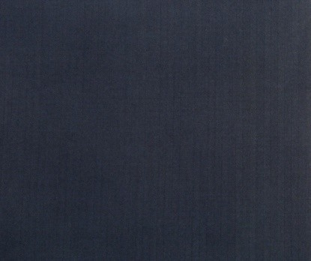

Figure 4.1: Herringbone fabric

## Sewing Thread

Commercially available & popular polyester sewing threads of same color with same ticket number was used for this study. In the sewing section, 30 Tex thread was used as sewing thread.

## Methods

* + 1. **Lock Stitch Sewing Machine**

Industrial lockstitch sewing machine was used to join different components of blazers. The complete specification of the machines is given below:

|  |  |
| --- | --- |
| Machine Name | Lockstitch sewing machine |
| No. of Thread | 02 |
| Brand Name | Jack |
| Manufacturers Name | Jack sewing machine co. ltd. |
| Country of Origin | China |
| Model No | L818F-M1 |
| Quantity | 76 Set |
| Application | To produce lock stitch |

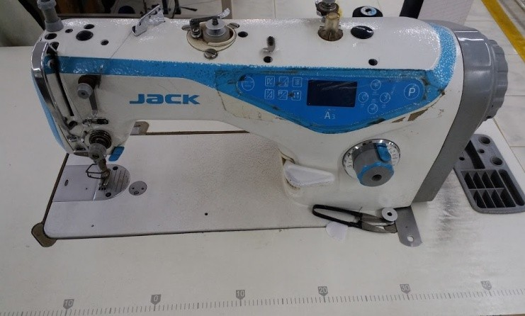

Figure 4.3: Lockstitch sewing machine.

Times New Roman Font size 22



**CHAPTER FIVE RESULTS AND DISCCUSSIONS**

Times New Roman Font size 22

# CHAPTER FIVE: RESULTS AND

Times New Roman Font size 12

**DISCCUSSIONS**

## SMV

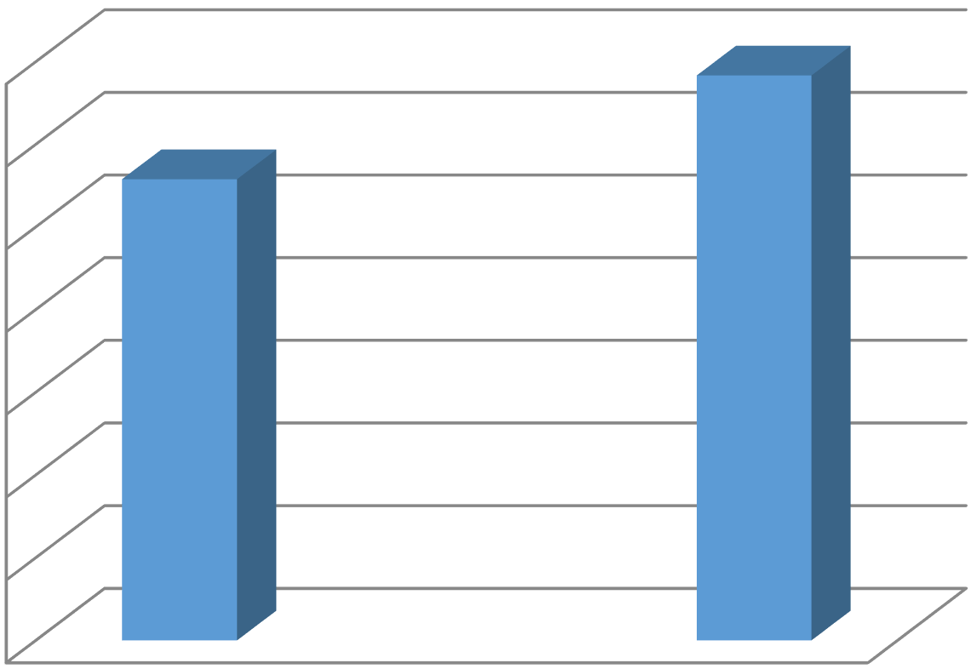

70

60

50

40

30

20

10

0

Figure 6.1: SMV

From the figure 6.1, we have found that the standard minute value (SMV) of

## Calculation of SMV



Times New Roman Font size 22



**CHAPTER SIX CONCLUSION**

Times New Roman Font size 12

Times New Roman Font size 22

# CHAPTER SIX: CONCLUSION

* 1. **Conclusion** aaaaaaaaaaaaaaaaaaaaaaaaaaaaaaaaaaaaaaaaaaaaaaaaaaaaaaaaaaaaaaaaaaaaaaaaaaaaa aaaaaaaaaaaaaaaaaaaaaaaaaaaaaaaaaaaaaaaaaaaaaaaaaaaaaaaaaaaaaaaaaaaaaaaaaaaaa aaaaaaaaaaaaaaaaaaaaaaaaaaaaaaaaaaaaaaaaaaaaaaaaaaaaaaaaaaaaaaaaaaaaaaaaaaaaa aaaaaaaaaaaaaaaaaaaaaaaaaaaaaaaaaaaaaaaaaaaaaaaaaaaaaaaaaaaaaaaaaaaaaaaaaaaaa aaaaaaaaaaaaaaaaaaaaaaaaaaaaaaaaaaaaaaaaaaaaaaaaaaaaaaaaaaaaaaaaaaaaaaaaaaaaa aaaaaaaaaaaaaaaaaaaaaaaaaaaaaaaaaaaaaaaaaaaaaaaaaaaaaaaaaaaaaaaaaaaaaaaaaaaaa aaaaaaaaaaaaaaaaaaaaaaaaaaaaaaaaaaaaaaaaaaaaaaaaaaaaaaaaaaaaaaaaaaaaaaa.

## Limitations

During the project work there were some drawbacks. These are stated below:

* + 1. It would be better if the number.
    2. There might have been some avoidable human errors
    3. The skills of all the manpower used were considered
    4. This project was only conducted on single type of garments

# REFERENCES

Times New Roman Font size 22

[1]. https://rmgbd.net/2018/05/bangladesh-rmg-industry/

[2]. Hasan, K. F., Rahman Abdur, "Role of textile and clothing industries in the growth and development of trade & business strategies of Bangladesh in the global economy"; International Journal of Textile Science 5.2, page 39-48; (2006).

[3]. Hasan, K. F., Rahman Abdur, "Role of textile and clothing industries in the growth and development of trade & business strategies of Bangladesh in the global economy"; International Journal of Textile Science 5.2, page 39-48; (2006).

[4]. Hasan, K. F., Rahman Abdur, "Role of textile and clothing industries in the growth and development of trade & business strategies of Bangladesh in the global economy"; International Journal of Textile Science 5.2, page 39-48; (2006).

**Spine format will be as follows**

|  |  |  |
| --- | --- | --- |
| **B.Sc.**  **Project work** | **Surface Modification of Cotton Fabric to Improve Dye ability with Natural Dyes** | **Sep, 2021** |

## || Surface Modification of Cotton Fabric to Improve Dye ability with Natural Dyes ||

**B.Sc.**

**Project work**

**Sep, 23**